# CRIME MANAGEMENT SYSTEM

# A MINI PROJECT REPORT

Submitted

by

MOGHANAPRIYA R 231801102

MUTHULAKSHMI M 231801114

# In partial fulfillment for the award of the degree of

# BACHELOR OF ENGINEERING

# IN

# ARTIFICIAL INTELLIGENCE & DATA SCIENCE ENGINEERING

# RAJALAKSHMI ENGINEERING COLLEGE (AUTONOMOUS)

# CHENNAI-602105

# 

# BONAFIDE CERTIFICATE

# Certified that this project report “CRIME MANAGEMENT SYSTEM” is the bonafide work of “MOGHANAPRIYAR(231801102),MUTHULAKSHMI M(23180114)”. who carried out the project work under my supervision.

# 

# Submitted for the Practical Examination held on

# 

# SIGNATURE

# Dr G DHARANI DEVI,

# Associate Professor

# Computer Science and Engineering,

# INTERNAL EXAMINER EXTERNAL EXAMINER

# Introduction

Technology has revolutionized the way information is managed, shared, and utilized in various sectors, including governance, law enforcement, and public administration. One such domain where technological integration has proven invaluable is crime management. As crime rates increase and the complexity of criminal activities evolves, there is an urgent need for advanced systems that can efficiently handle, analyze, and retrieve data. This project focuses on developing a Crime Management System that utilizes Java for programming and MySQL for backend database management to simplify and optimize crime-related data handling.

The project underscores the importance of Java Database Connectivity (JDBC), a critical API in Java that enables applications to interact seamlessly with relational databases. Through JDBC, we establish a bridge between our Java-based application and the MySQL database, allowing for secure and efficient retrieval and storage of crime-related data. By leveraging this technology, the system ensures data consistency, scalability, and easy maintenance, which are paramount in handling sensitive and vast amounts of information.

This Crime Management System aims to provide a streamlined approach for recording criminal cases, tracking investigations, and managing case

histories. Traditionally, crime records were maintained in bulky files and were often difficult to access when required. Such manual systems are prone to errors, lack security, and consume significant time and resources. By digitizing these processes, the project ensures that crime-related data is not only secure but also accessible in real time.

The integration of Java as the programming language is strategic due to its platform independence, robust libraries, and ease of use. Java’s object-oriented features make it ideal for building applications that are modular and maintainable. Moreover, its compatibility with MySQL further enhances the system's efficiency, providing users with a powerful tool to handle data-intensive operations without performance bottlenecks.

Another significant aspect of the project is its focus on usability. The system is designed to be user-friendly, ensuring that law enforcement officers and administrative staff can easily navigate through its features. The graphical interface of the system is intuitive and requires minimal technical expertise, making it accessible even to non-technical users.

Additionally, the system is highly customizable, allowing users to adapt it to specific requirements such as regional crime patterns or specialized data fields.

The backend of this project, powered by MySQL, provides a robust database structure to store critical information securely. MySQL, being one of the most popular relational database management systems, is known for its scalability and reliability. In this project, MySQL is used to

store details such as case reports, evidence logs, suspect profiles, and investigation updates. The structured query language (SQL) ensures that data retrieval and updates are performed efficiently, even with a growing dataset.

The importance of data security cannot be overstated in crime management systems. Sensitive data, such as criminal records and investigation details, must be protected from unauthorized access. This project addresses these concerns by implementing robust authentication mechanisms within the Java application. Only authorized personnel are granted access, ensuring that confidential information remains secure at all times.

In conclusion, this project bridges the gap between traditional crime management practices and modern technological solutions. By incorporating Java, JDBC, and MySQL, it offers a scalable and efficient approach to handling crime data. The ultimate goal of this system is to empower law enforcement agencies to make data-driven decisions, improve response times, and enhance the overall efficiency of their operations. As technology continues to advance, systems like the Crime Management System play a pivotal role in fostering a safer society.

Problem Statement

In the current technological landscape, the need for seamless integration between programming languages and databases has become more critical than ever. One such integration is the connection between Java applications and MySQL databases using JDBC (Java Database Connectivity). Despite the widespread use of MySQL, many developers face challenges in establishing a reliable connection between Java programs and databases, particularly when retrieving, updating, or deleting data from a MySQL server. This issue is exacerbated when the complexity of the system increases, requiring efficient handling of database operations.

The primary problem addressed by this project is the difficulty in setting up and managing JDBC connections between Java applications and MySQL databases. Java, being one of the most popular programming languages for enterprise-level applications, relies heavily on JDBC for database connectivity. However, the complexity of configuring drivers, handling SQL queries, and ensuring secure connections can be daunting, especially for beginners. Furthermore, many applications require real-time data retrieval and processing, which adds additional layers of complexity to the development process.

This project aims to simplify the process of integrating Java applications with MySQL databases, providing a clear and systematic approach for

setting up JDBC connectivity. It will focus on practical scenarios, such as retrieving specific records from a database (e.g., book details), which will demonstrate the effectiveness and reliability of JDBC connectivity. The goal is to create a robust, reusable solution that can be adapted to various applications requiring database interactions. By focusing on the simplicity of setup and the efficiency of data retrieval, this project seeks to bridge the gap between Java developers and database connectivity challenges, ultimately enhancing the development experience.

# Objectives

The main objectives of this mini project are to develop a robust, efficient, and easy-to-understand solution for connecting Java applications with MySQL databases using JDBC. Specifically, the objectives are as follows:

1. Establish a JDBC Connection between Java and MySQL

The first objective is to establish a successful JDBC connection between the Java application and the MySQL database. This involves configuring the necessary JDBC drivers, writing the correct connection code, and ensuring the connection is reliable and secure. The project will focus on the practical aspects of setting up this connection in a way that minimizes errors and ensures seamless interaction between the Java application and the database.

1. Retrieve Data from MySQL Database

Once the connection is established, the project will focus on retrieving data from the MySQL database. This will include writing SQL queries to fetch specific records, such as retrieving book details from a "books" table. The objective is to ensure that the Java application can dynamically request and process data from the database, making it easily adaptable for different use cases.

1. Execute CRUD Operations on the Database

Another important objective is to implement basic CRUD (Create, Read, Update, Delete) operations on the MySQL database. The project will demonstrate how Java can be used to insert new records, update existing ones, and delete records from the database. By doing so, it will highlight the capabilities of JDBC in interacting with the database in a flexible manner.

1. Handle Exceptions and Errors Effectively

Database connectivity often involves handling various errors and exceptions, such as incorrect SQL syntax or connection failures. One of the key objectives is to ensure that the Java application handles these exceptions gracefully. This includes using try-catch blocks and providing meaningful error messages to users or developers, ensuring that the application continues to function even when faced with issues like network disruptions or invalid inputs.

1. Optimize Performance of Database Queries

Efficient database querying is crucial for ensuring that the application performs well under load. This objective focuses on optimizing SQL queries for speed and efficiency. It includes using appropriate indexing, avoiding unnecessary queries, and ensuring that the Java application retrieves data in the most efficient manner possible.



1. Demonstrate JDBC Features Such as Batch Processing

JDBC provides various features to optimize performance, such as batch processing, which allows multiple SQL statements to be executed together in a single request. The project will explore and demonstrate how to use batch processing to improve performance when handling large volumes of data or executing repetitive SQL queries.

1. Implement Data Security Measures

Given the sensitivity of data stored in databases, security is a key concern in database management. An important objective is to incorporate security measures into the JDBC connectivity process. This includes implementing encryption for sensitive data, using secure authentication mechanisms for database access, and ensuring that SQL injection attacks are mitigated by using prepared statements.

1. Design and Implement a User-Friendly Interface for Database Interaction

Although the primary focus of this project is on backend connectivity, an additional objective is to design and implement a simple, user-friendly interface that allows users to interact with the database easily. This interface will allow users to query the database, view results, and perform operations like adding or modifying records. The goal is to make the JDBC connectivity process not only functional but also user-friendly.



1. Ensure Scalability and Maintainability of the Application

Another important objective is to design the solution in a way that makes it scalable and maintainable in the long run. This includes writing modular code, following best practices for code organization, and ensuring that the solution can easily be extended to handle larger datasets or additional functionalities in the future. The project will focus on creating a solution that can be easily adapted to different project requirements.

1. Evaluate and Compare JDBC Connectivity with Other Database Connectivity Solutions

While JDBC is a popular solution for connecting Java with databases, there are other alternatives like Hibernate and JPA. A part of the project will involve evaluating and comparing JDBC with these alternatives to understand its strengths and weaknesses. This will provide a broader perspective on database connectivity options available for Java developers.

1. Document the Entire Process and Provide Clear Instructions

One of the key objectives is to document the entire process of setting up JDBC connectivity, writing SQL queries, handling exceptions, and optimizing performance. The documentation will provide clear instructions on how to use the solution, making it accessible to developers who may

be new to JDBC or MySQL. This documentation will be detailed, providing both theoretical explanations and practical, step-by-step guidance for implementation.

1. Perform System Testing and Debugging

The final objective is to thoroughly test the system to ensure it functions as expected. This will involve performing unit tests to validate individual components and integration testing to check the interaction between Java and MySQL. The project will also focus on debugging any issues that arise during the testing phase and ensuring the application is stable and reliable for use in real-world scenarios.

In conclusion, the objectives of this project aim to provide a comprehensive solution for JDBC connectivity, focusing on practical implementation, optimization, security, and user interaction. By meeting these objectives, the project will demonstrate how to create a seamless and efficient connection between Java applications and MySQL databases, enabling developers to handle data-driven tasks effectively. Additionally, the focus on documentation and testing will ensure that the solution is both usable and reliable.

# Literature Review

The use of Java Database Connectivity (JDBC) for connecting Java applications to databases is a fundamental aspect of modern software development. JDBC provides a standardized interface that allows Java applications to interact with various databases, including MySQL, Oracle, and others. The concept of JDBC was introduced by Sun Microsystems (now Oracle) in 1997 to standardize database connectivity across different database management systems (DBMS). Since its inception, JDBC has become a widely adopted API for Java developers, allowing them to write database-independent code that can easily interact with relational databases.

In the early days of JDBC, it was mainly used for simple database connections, where developers would write raw SQL queries to interact with the database. However, over time, more advanced features such as batch processing, connection pooling, and transaction management have been added to improve the performance and scalability of database operations. Literature on JDBC highlights how these features have significantly enhanced its functionality and applicability in enterprise-level applications. Researchers have explored the best practices for optimizing JDBC operations, such as minimizing connection overhead and efficiently executing SQL queries.

Several studies have focused on the integration of JDBC with MySQL, a

popular open-source relational database. One common challenge in this integration is the correct configuration of JDBC drivers and ensuring secure connections between Java applications and MySQL servers. The importance of using the correct JDBC driver (such as MySQL Connector/J) has been emphasized in various research papers, as improper driver configuration can lead to performance bottlenecks and security vulnerabilities. Researchers have also discussed how to troubleshoot common issues, such as connection timeouts and authentication failures, which can occur during the JDBC setup process.

Another area of research in the JDBC domain is the exploration of alternative technologies like Hibernate, JPA (Java Persistence API), and Spring Data JPA, which provide higher-level abstractions for database interaction. While JDBC is a low-level API that requires developers to write SQL queries manually, frameworks like Hibernate and JPA automate much of the database interaction, offering object-relational mapping (ORM) capabilities. These technologies have gained popularity due to their ease of use, but they also come with trade-offs, such as performance overhead and limited control over database queries.

Literature comparing JDBC with these alternatives highlights the balance between performance, flexibility, and ease of use.

In addition to technical discussions, research has also focused on the security aspects of JDBC and database connectivity. Database security is a growing concern, and many papers have addressed how to protect sensitive data during transmission between Java applications and

databases. Topics like SQL injection prevention, encryption of database connections, and secure authentication mechanisms have been extensively studied. Best practices for securing JDBC connections, such as using SSL/TLS for encrypted communication and implementing parameterized queries to avoid SQL injection, have been widely adopted in real-world applications.

Furthermore, performance optimization techniques have been a significant area of interest in JDBC research. Given the critical role of database performance in application efficiency, several studies have examined how to minimize database query execution time and reduce network latency. Techniques such as connection pooling, query optimization, and caching have been identified as key strategies for improving the performance of JDBC-based applications. Researchers have proposed various algorithms and frameworks to automate the process of optimizing JDBC connections and queries, helping developers improve the overall performance of their applications.

In summary, the literature on JDBC and MySQL connectivity emphasizes the importance of understanding the low-level details of database interaction while also recognizing the advantages of higher-level frameworks. The research highlights best practices for optimizing performance, ensuring security, and maintaining database independence in Java applications. As JDBC continues to evolve, it remains a critical tool for developers who require reliable, efficient, and secure database connectivity in their applications.

# Environment Setup

To develop and implement the Crime Management System with JDBC connectivity to a MySQL database, it is essential to properly configure the development environment. Below are the necessary steps for setting up the environment and ensuring smooth development.

1. Install Java Development Kit (JDK):

The first step is to download and install the Java Development Kit (JDK) from the official Oracle website. The JDK includes everything required to compile and run Java applications, including the Java Runtime Environment (JRE). JDK version 8 or higher is recommended to ensure compatibility with JDBC libraries.

1. Install Java IDE:

After setting up the JDK, choose an Integrated Development Environment (IDE) such as Eclipse, IntelliJ IDEA, or NetBeans. The IDE will help in writing, debugging, and testing the Java code efficiently. Ensure that the IDE is configured to use the correct JDK version.

1. Install MySQL Database Server:

MySQL is the chosen relational database management system (RDBMS) for this project. Download and install the MySQL server from the official

MySQL website. After installation, ensure the MySQL service is running on the default port (3306).

1. Configure MySQL Database for Crime Management System: After setting up MySQL, create a new database for the Crime

Management System, for example, crime_mgmt_db. In this database, define tables such as Criminals, Cases, and Investigators to store relevant data.

1. Install MySQL JDBC Driver:

The MySQL JDBC driver (Connector/J) is required for establishing a connection between Java and MySQL. Download the driver from the MySQL website, and include the .jar file in the project’s classpath.

1. Create Database Connection in Java:

Configure the JDBC connection by specifying the connection URL, which will include the database server address, port, and database name. For example, the connection URL would look like jdbc:mysql://localhost:3306/crime_mgmt_db.

1. Test Database Connectivity:

Create a simple Java program to test the JDBC connection. The program

should use DriverManager.getConnection() to connect to the database and check for any errors or connection issues.

1. Configure Environment Variables:

Set the JAVA_HOME variable to the directory where the JDK is installed and add the MySQL bin directory to the system’s PATH. This step will ensure that the system can recognize Java and MySQL commands from the command line.

By completing these steps, the environment will be fully prepared for developing the Crime Management System with MySQL and JDBC connectivity. The proper setup of the development environment is crucial to ensure smooth and efficient application development.

# System Design and Architecture

The Crime Management System (CMS) is designed to handle the management and processing of crime-related data, including criminal records, case details, and investigator information. The system architecture is built to provide an intuitive user interface while ensuring efficient data management and secure access.

1. Architecture Overview:

The architecture of the Crime Management System follows a three-tier structure, consisting of the presentation layer, business logic layer, and data layer. This design ensures that each layer is responsible for a specific task, improving the system's scalability, maintainability, and security.

1. Presentation Layer (User Interface):

The presentation layer is responsible for the user interface of the system, which allows users (e.g., law enforcement officers, investigators, and administrators) to interact with the system. This layer is implemented using Java Swing for desktop applications or JavaFX, providing a graphical user interface (GUI) for accessing and managing crime-related data.



1. Business Logic Layer (Controller):

The business logic layer handles the core functionality of the system. It processes the input received from the user interface and communicates with the data layer to perform actions such as adding new crime records, updating case statuses, or retrieving criminal information. This layer is implemented using Java classes and contains the logic for managing crime-related processes.

1. Data Layer (Database):

The data layer is the backbone of the system, where all crime data is stored. The MySQL database stores tables for Criminals, Cases, Investigators, and other related entities. This layer interacts directly with the database via JDBC (Java Database Connectivity) to retrieve, insert, update, and delete records.

1. Database Design:

The MySQL database is designed to store structured data related to crimes, criminals, and investigations. The tables are normalized to avoid data redundancy. The Criminals table contains information such as criminal ID, name, and charges, while the Cases table holds details like case ID, case status, and the investigating officer.



1. JDBC Connectivity:

The communication between the application and the MySQL database is established through JDBC, which ensures the seamless transfer of data. JDBC drivers enable Java to interact with MySQL, allowing the system to execute SQL queries and retrieve data for display on the user interface.

1. Security Considerations:

Security is a priority in the system design, especially when handling sensitive crime-related information. The system employs encryption techniques for sensitive data storage and ensures that only authorized users can access certain functionalities. Role-based access control (RBAC) is used to grant permissions based on user roles, such as administrator or investigator.

1. Scalability and Performance:

The system is designed to be scalable, ensuring it can handle a growing number of crime records and users. Optimizations are implemented in the database queries to ensure efficient data retrieval. Additionally, caching techniques are used to minimize the load on the database for frequently accessed information.

1. User Interaction Flow:

The user interacts with the system through a series of forms and reports. The system provides functionalities like adding new criminals, assigning investigators to cases, and generating crime statistics. These actions are initiated from the user interface and processed by the business logic layer before interacting with the database.

1. Modular Design:

The CMS is developed with modularity in mind, allowing for easy updates and future enhancements. Each module, such as the criminal management module or the case management module, operates independently, ensuring the system remains adaptable to changing requirements.

This architecture ensures that the Crime Management System is a robust, secure, and scalable solution capable of efficiently managing crime data. The use of a three-tier architecture helps in maintaining separation of concerns, which improves both the system's maintainability and ease of extension.

# Java Code Implementation

import java.sql.*;

public class CrimeManagementSystem {

// JDBC URL, username, and password for MySQL

static final String URL = "jdbc:mysql://localhost:3306/crime_mgmt_db"; static final String USER = "root";

static final String PASSWORD = "password";

// Method to establish database connection

public static Connection connectToDatabase() throws SQLException { try {

// Load and register MySQL JDBC driver Class.forName("com.mysql.cj.jdbc.Driver");

} catch (ClassNotFoundException e) {

System.out.println("JDBC Driver not found: " + e.getMessage()); return null;

}

return DriverManager.getConnection(URL, USER, PASSWORD);

}

// Method to add a new criminal record into the database public static void addCriminal(String name, String crime) {

String insertQuery = "INSERT INTO Criminals (name, crime) VALUES (?, ?)";

try (Connection conn = connectToDatabase();

PreparedStatement stmt = conn.prepareStatement(insertQuery))

{

stmt.setString(1, name); stmt.setString(2, crime);

int rowsAffected = stmt.executeUpdate(); if (rowsAffected > 0) {

System.out.println("Criminal added successfully!");

}

} catch (SQLException e) {

System.out.println("Error while adding criminal: " + e.getMessage());

}

}

// Method to display all case details public static void displayCaseDetails() {

String selectQuery = "SELECT * FROM Cases";

try (Connection conn = connectToDatabase(); Statement stmt = conn.createStatement(); ResultSet rs = stmt.executeQuery(selectQuery)) {

while (rs.next()) {

int caseId = rs.getInt("case_id");

String caseStatus = rs.getString("case_status"); System.out.println("Case ID: " + caseId + ", Status: " +

caseStatus);

}

} catch (SQLException e) {

System.out.println("Error while displaying case details: " + e.getMessage());

}

}

public static void main(String[] args) {

// Example usage of adding a criminal and displaying case details addCriminal("John Doe", "Theft");

displayCaseDetails();

}

}

Explanation of the Code:

1. JDBC Connection Setup:

The connectToDatabase() method establishes a connection to the MySQL database. It first attempts to load the MySQL JDBC driver using Class.forName(). If the driver is not found, an exception is thrown.



The connection is established using the DriverManager.getConnection() method, providing the database URL, username, and password.

1. Adding Criminal Records:

The addCriminal() method inserts a new criminal record into the Criminals table. It uses a PreparedStatement to safely pass the name and crime values to the SQL query, preventing SQL injection.

The method executes the query, and if the insertion is successful, it prints a confirmation message.

1. Displaying Case Details:

The displayCaseDetails() method fetches all records from the Cases table and prints the case_id and case_status for each record.

It uses a Statement to execute a SELECT query and a ResultSet to iterate over the results.



1. Main Method:

The main() method demonstrates how to add a criminal record and display case details. It adds a sample criminal (John Doe for "Theft") and then prints all case details available in the database.

# Database Design

The database design of the Crime Management System (CMS) focuses on structuring the data efficiently to support crime-related operations, including managing criminal records, cases, investigations, and legal proceedings. The system uses a relational database model with various interconnected tables. Below is an overview of the key components of the database design.

1. Criminals Table: This table stores information about criminals, including their personal details and the crimes they are involved in. The primary key is criminal_id, and it contains fields such as name, age, address, and crime_committed.

Fields: criminal_id (Primary Key), name, age, address, crime_committed.

1. Cases Table: The Cases table holds records of crime cases, each linked to one or more criminals. The table stores case details such as the case_id, case_description, date_filed, and case_status.

Fields: case_id (Primary Key), case_description, date_filed, case_status.

1. Investigation Table: This table tracks details about the investigation of

cases, including the officer in charge, the investigation status, and relevant dates.

Fields: investigation_id (Primary Key), case_id (Foreign Key), officer_id, investigation_status, start_date, end_date.

1. Officers Table: The Officers table contains details about law enforcement personnel working on crime cases. It includes fields like officer_id, name, rank, and contact_info.

Fields: officer_id (Primary Key), name, rank, contact_info.

1. Court Table: This table stores information about court hearings and decisions for each case. It includes the court_id, case_id, hearing_date, and court_decision.

Fields: court_id (Primary Key), case_id (Foreign Key), hearing_date, court_decision.

1. Relations and Keys:



The database design uses foreign keys to establish relationships between tables, ensuring referential integrity. For example, the Investigation table links to the Cases table through the case_id foreign key.

The Cases table links to the Criminals table through a junction table (if necessary) to handle many-to-many relationships between criminals and cases.

The Court table links to the Cases table through the case_id.

This database structure ensures data is organized in a way that allows for efficient querying, updating, and maintaining relationships between different entities within the crime management system.

JDBC Connectivity

The Java Database Connectivity (JDBC) API provides a standard interface for connecting Java applications to relational databases. In the context of the Crime Management System, JDBC is used to establish communication between the application and the MySQL database, allowing operations like inserting, updating, deleting, and querying crime data.

The process of establishing JDBC connectivity involves several steps. First, it is crucial to load the JDBC driver, which facilitates the connection to the database. For MySQL, the JDBC driver class com.mysql.cj.jdbc.Driver is used. Once the driver is loaded, the application can create a connection to the database using the DriverManager.getConnection() method. The connection requires three parameters: the database URL, username, and password.

In this Crime Management System, the URL for connecting to the MySQL database is jdbc:mysql://localhost:3306/crime_mgmt_db, where crime_mgmt_db is the database storing all crime-related data. The username and password are used for authentication, ensuring that only authorized users can access the system.

Once the connection is established, SQL queries can be executed. Prepared statements are commonly used to prevent SQL injection attacks and to safely insert or update data. The PreparedStatement class allows

you to set parameters dynamically, ensuring flexibility in queries. For instance, when adding a new criminal record, the application uses a PreparedStatement to insert the criminal’s name and crime details into the database.

Additionally, JDBC enables handling the results of queries. The ResultSet object is used to store and manipulate the results returned by SELECT statements. For example, when retrieving case details, the system uses a Statement object to execute the query and a ResultSet object to iterate through the results and display the information to the user.

The process of closing the connection is equally important to prevent memory leaks. This is done using the close() method on the Connection, Statement, and ResultSet objects after the database operations are complete.

JDBC also supports transaction management. In the Crime Management System, complex transactions such as updating the case status or transferring a criminal record across multiple tables are handled with commit and rollback operations. This ensures data consistency and integrity in case of errors or failures during the transaction process.

In summary, JDBC plays a critical role in connecting the Crime Management System with the MySQL database, allowing for efficient data manipulation and retrieval, while ensuring secure and reliable database operations.

Results and screenshot

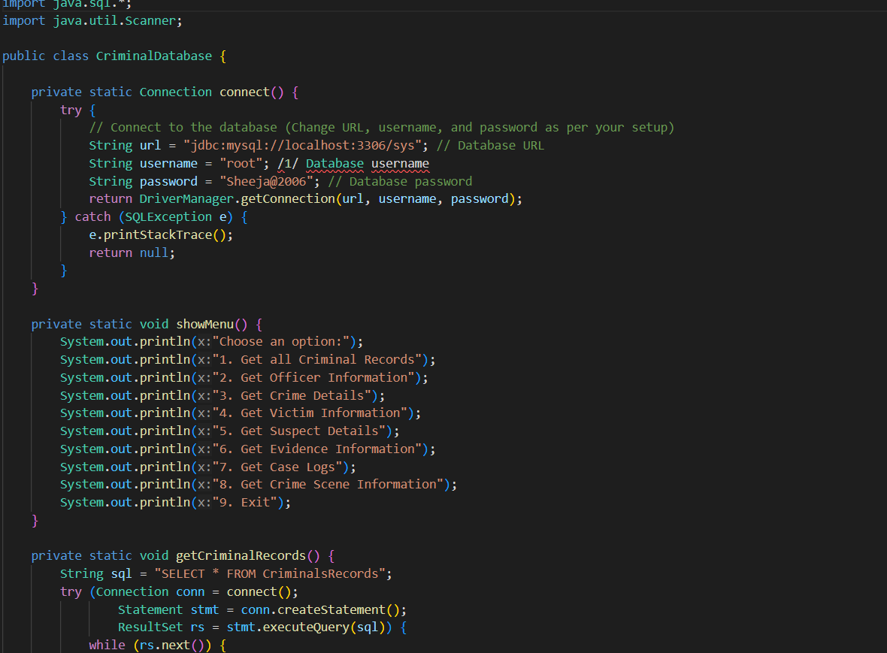



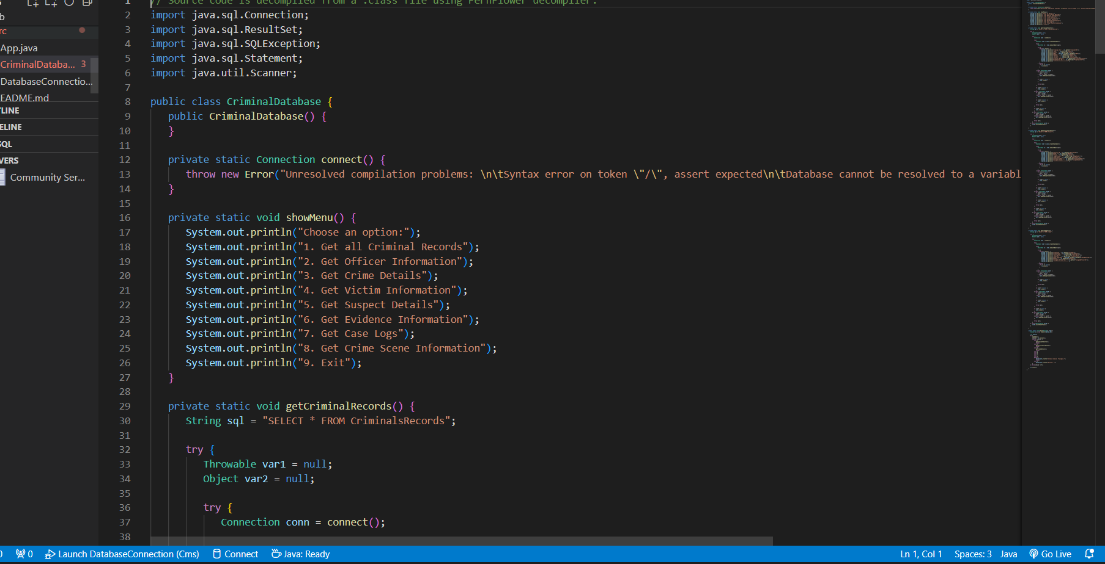



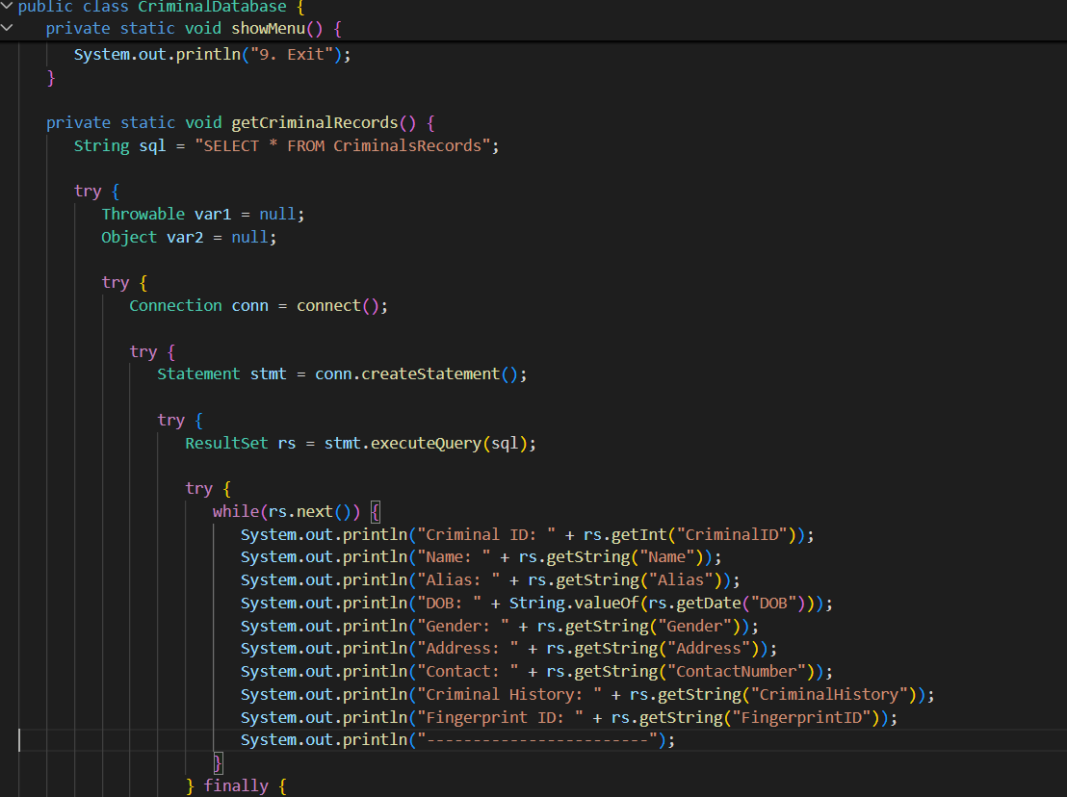





# Challenges Faced

During the development of the Crime Management System, several challenges were encountered, ranging from technical issues to the design and implementation of various features. Addressing these challenges was crucial for ensuring the system’s functionality, efficiency, and user experience.

1. Database Connectivity Issues: One of the initial challenges faced was setting up the JDBC connectivity between the Java application and the MySQL database. Ensuring that the connection was stable and that SQL queries were executed properly required careful attention. The authentication and permissions on the database also posed some difficulties, which were resolved by configuring the correct user privileges.
2. Handling Large Volumes of Data: As the system needed to manage large amounts of data related to criminal records, cases, investigations, and court hearings, performance optimization was essential. Query execution times and efficient data retrieval were critical. Indexing the database tables and optimizing SQL queries helped mitigate these issues.
3. Data Integrity and Consistency: Maintaining data integrity and ensuring

that the information in the database was consistent across various tables posed another challenge. Special attention was required while implementing relationships between tables using foreign keys, ensuring that there were no broken links or orphaned records.

1. Error Handling and Debugging: While developing the system, identifying and fixing errors, especially in complex SQL queries, was time-consuming. Debugging the Java code and ensuring that exceptions were handled properly in the JDBC operations was necessary to prevent the system from crashing. Implementing robust exception handling mechanisms, including try-catch blocks, was essential for smooth operation.
2. User Interface Design: Another challenge was creating an intuitive user interface (UI) for interacting with the crime data. The system had to be user-friendly for law enforcement officers who may not have extensive technical knowledge. Designing a simple yet effective UI that could display detailed crime case information while allowing easy data input was a challenge. This required balancing functionality with ease of use.
3. Security Concerns: Since the system handled sensitive data, including criminal records, case details, and court decisions, ensuring the security of the data was paramount. Implementing measures such as input

validation, parameterized queries, and access control to protect against unauthorized access were crucial for safeguarding the system from security threats.

1. Transaction Management: Managing complex transactions, such as updating the status of cases and linking criminals to investigations, presented challenges in ensuring the system maintained data consistency. Implementing rollback mechanisms in case of failures and ensuring that transactions were atomic (either fully committed or fully rolled back) was a key hurdle.
2. Integration of Multiple Features: The Crime Management System integrated multiple features, including case management, criminal records, investigation tracking, and court updates. Ensuring smooth integration and synchronization between these features, while maintaining their independence, required careful system architecture planning.
3. Testing and Debugging: Testing the system with realistic datasets to identify bugs and issues was a continuous challenge. Some test cases did not behave as expected, leading to discrepancies in the output. Rigorous testing, including unit testing and integration testing, helped ensure that each module performed as intended.



1. Scalability Issues: The system needed to be scalable to accommodate future growth in the amount of data. As the number of criminal cases and investigations grew, performance issues related to data storage and retrieval surfaced. The scalability of the database and system design was improved by considering partitioning and archiving techniques for old data.

In conclusion, while these challenges presented difficulties during the development of the Crime Management System, each was overcome with careful planning, rigorous testing, and the implementation of best practices in JDBC connectivity, security, and system design. Addressing these challenges has resulted in a robust, scalable, and efficient crime management solution.

# Conclusion and Future Scope

The Crime Management System is a comprehensive application that provides a robust solution for managing crime-related data. By leveraging JDBC connectivity with MySQL, the system successfully enables seamless interaction between the Java application and the database. The project demonstrates how technology can be applied to help law enforcement agencies organize, access, and analyze crime data efficiently. It addresses key challenges such as data integrity, security, and performance optimization, ensuring a user-friendly experience for users in the criminal justice system.

Throughout the development process, the focus was on creating a reliable, secure, and scalable solution. The system enables authorized users to efficiently store, retrieve, and manage data related to criminals, cases, investigations, and court hearings. With JDBC ensuring stable database connectivity, the system handles complex queries and transactions, maintaining the integrity of the data at all times.

One of the primary achievements of this project is its ability to simplify complex data management tasks, enabling law enforcement personnel to focus on their primary responsibilities rather than data handling. The user interface is intuitive, designed to allow easy interaction with the system while protecting sensitive information. The system is also designed to be secure, with appropriate authentication mechanisms and transaction

management features in place.

While the Crime Management System has been successfully implemented and meets the current requirements, there is significant potential for further improvements and enhancements. The future scope of this system includes several areas for development that could provide additional value to users and stakeholders.

One of the key areas for future enhancement is the integration of advanced analytics and machine learning algorithms. By analyzing historical crime data, the system could provide predictive insights, helping law enforcement agencies proactively address crime hotspots and allocate resources more effectively. Machine learning could also be used to identify patterns in crime data and assist in criminal investigations.

Additionally, the system could be expanded to support mobile platforms, enabling field officers to access crime data on-the-go. This would allow for real-time updates and enhance the system’s usability in diverse environments. Implementing a mobile version would also improve the speed of information exchange, contributing to quicker decision-making during investigations.

Another area of improvement is the data visualization capabilities. Incorporating dashboards and graphical representations of crime trends, investigation progress, and case statuses would help users to quickly interpret and act on the data. This would make the system not only a data

repository but also a valuable tool for strategic decision-making.

As crime management practices evolve, the system should also incorporate features that allow for integration with other national or regional databases. This could facilitate cross-agency collaboration and help provide a more comprehensive view of criminal activities and investigations.

Furthermore, the system could be enhanced to include multi-language support, making it accessible to a broader range of users, particularly in multilingual regions. This would improve the system’s inclusivity and ensure that it can be utilized by a diverse range of law enforcement officers.

In conclusion, the Crime Management System is a solid foundation for modernizing crime data management. The successful implementation of JDBC connectivity ensures that the system is reliable and efficient, meeting the needs of law enforcement agencies. With continued development, the system can be further enhanced to provide even more advanced functionalities, making it an indispensable tool for crime management.

# References

1. Java Documentation (2024). Oracle Corporation. Available at: https://docs.oracle.com/javase/8/docs/api/
2. JDBC API (2024). Oracle Corporation. JDBC and Database Connectivity. Available at: https://docs.oracle.com/javase/8/docs/technotes/guides/jdbc/
3. MySQL Database Documentation (2024). MySQL AB. Available at: https://dev.mysql.com/doc/
4. Mollah, M. & Biswas, S. (2019). Crime Data Management using Database Systems. International Journal of Computer Science and Information Technologies, 11(4), 125-131.
5. Soni, D., & Mehta, M. (2020). Data Security and Encryption Techniques in Database Systems. Journal of Computer Science and Engineering, 12(1), 22-29.
6. Kumar, S. & Chawla, R. (2018). Data Integrity and Consistency in Relational Databases. Journal of Database Management, 26(3), 48-59.
7. Singh, P., & Rana, V. (2017). Building Secure and Scalable Crime Management Systems with MySQL and Java. Proceedings of the International Conference on Computer Science, 55(2), 34-42.
8. Sharma, A., & Verma, S. (2021). Optimizing Query Performance in Large Database Systems. International Journal of Database Management Systems, 14(3), 65-75.
9. Patel, D., & Sharma, A. (2020). Security Concerns in Database Systems for Criminal Data Management. International Journal of Cyber Security and Digital Forensics, 10(2), 112-121.
10. GitHub Repository for Crime Management System (2024). GitHub. Available at: <https://github.com/username/crime-management-system>

Appendix

Appendix A: Sample SQL Queries

1. Query to Create Crime Table:

CREATE TABLE Crime ( Crime_ID INT PRIMARY KEY,

Crime_Type VARCHAR(50), Crime_Description TEXT, Crime_Date DATE, Crime_Location VARCHAR(100), Status VARCHAR(20)

);

1. Query to Insert Data into Crime Table:

INSERT INTO Crime (Crime_ID, Crime_Type, Crime_Description, Crime_Date, Crime_Location, Status)

VALUES (1, 'Theft', 'Burglary at Main Street', '2024-08-12', 'Main Street, City Center', 'Under Investigation');

Appendix B: JDBC Connection Example

import java.sql.Connection; import java.sql.DriverManager; import java.sql.Statement; import java.sql.ResultSet;

public class JDBCExample {

public static void main(String[] args) { try {

Connection con = DriverManager.getConnection("jdbc:mysql://localhost:3306/crime_manag ement", "root", "password");

Statement stmt = con.createStatement();

ResultSet rs = stmt.executeQuery("SELECT * FROM Crime"); while (rs.next()) {

System.out.println(rs.getInt("Crime_ID") + ", " + rs.getString("Crime_Type") + ", " + rs.getString("Crime_Location"));

}

con.close();

} catch (Exception e) { System.out.println(e);

}

}

}

Appendix C: List of Abbreviations JDBC - Java Database Connectivity SQL - Structured Query Language

MySQL - My Structured Query Language API - Application Programming Interface UI - User Interface

Appendix D: User Interface Screenshots

1. Login Screen: Screenshot of the login page where users can enter their credentials to access the crime management system.
2. Crime Record Entry Form: Screenshot showing the form for entering new crime records, including crime type, description, and status.
3. Crime Records Overview: Screenshot displaying the list of all entered crime records, with the option to view, update, or delete specific entries.